**PROBLEM STATEMENT:**

Perform wordcount operation in local mode (In windows environment). Share the code, explain the execution steps, and attach the output screenshot.

**DATASET:**

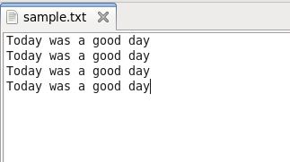

**SOLUTION:**

**PROGRAM:**

DRIVER CLASS

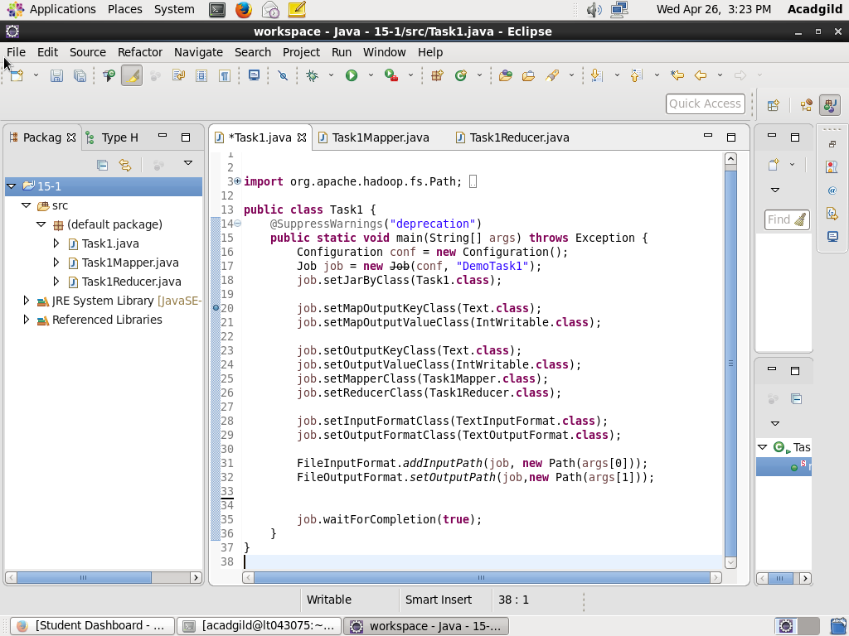

MAPPER CLASS

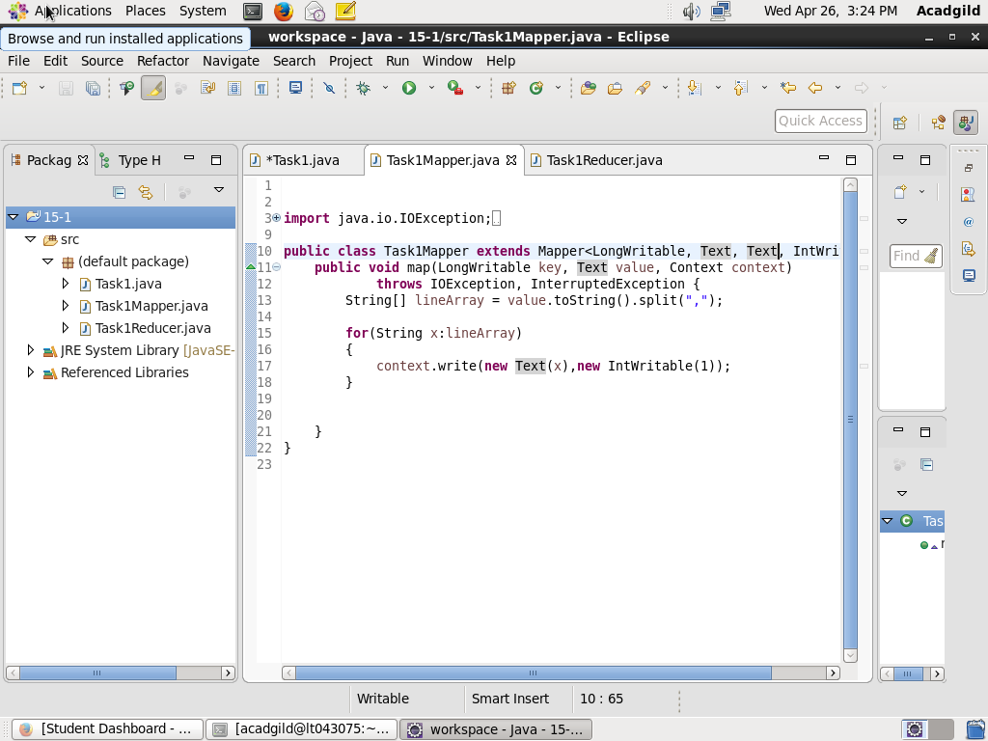

REDUCER CLASS

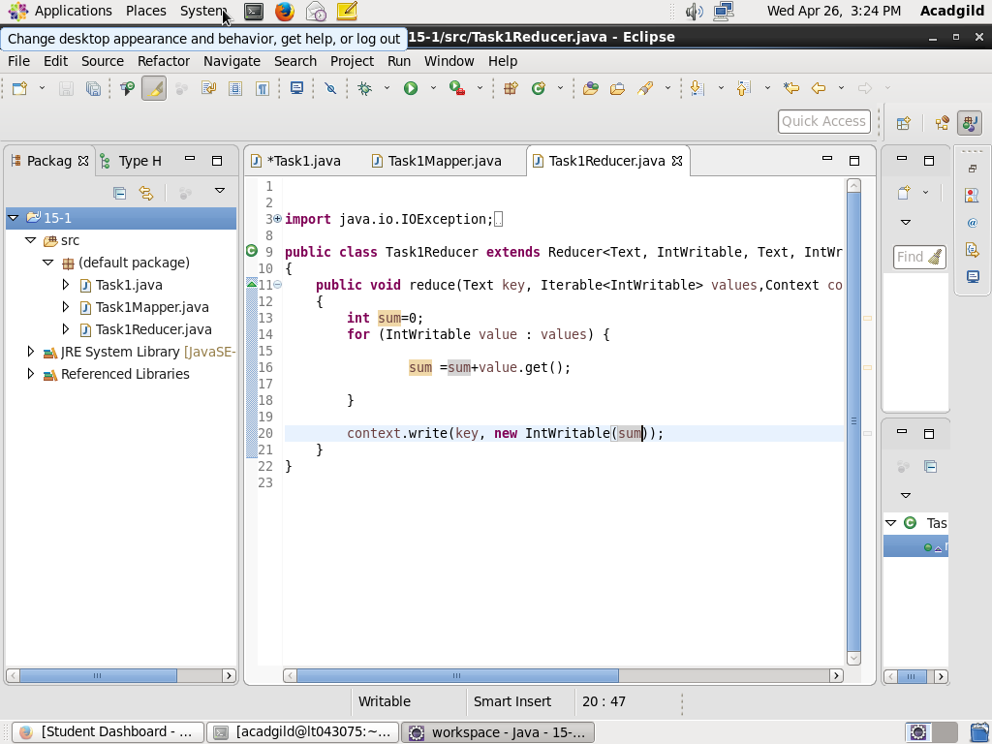

OUTPUT:

